# The new age of Digital Out-of-Home advertisement

Marketing and Advertising has a higher audience reach with impactful organic search

What distinguishes us, humans, from other animals? It will always be in our ability to think, to empathise and to feel.

These basic principles are eternally relevant and applicable to all fields. When we do write copy or design advertisements we not only want the general populace to see our advert but also connect with it. If they feel it, it improves traction tremendously. For example, the word of mouth is an important factor for newly released cinema, viral memes and songs. It is the same for an Out of Home impactful advert.

Statista predicts that even after the covid outbreak caused a significant dip of 2.8% to the OOH advertising industry, we will be seeing a net-positive growth of 17% in the first quarter of 2021.4

### The visual component of OOH adverts

We are visual beings. We see objects, movements and colours, we analyse and appreciate them to great effect. A visual stimulus always elicits a response be it conscious or subconscious. An Out-of-Home advert that is placed correctly is a surefire method of producing leads and audience engagement.

There are so many mediums to choose from for an OOH advert. It could be placements on a lamppost, bridges, Guerilla style advertisements, point of sale displays, transit ads and retail ads.

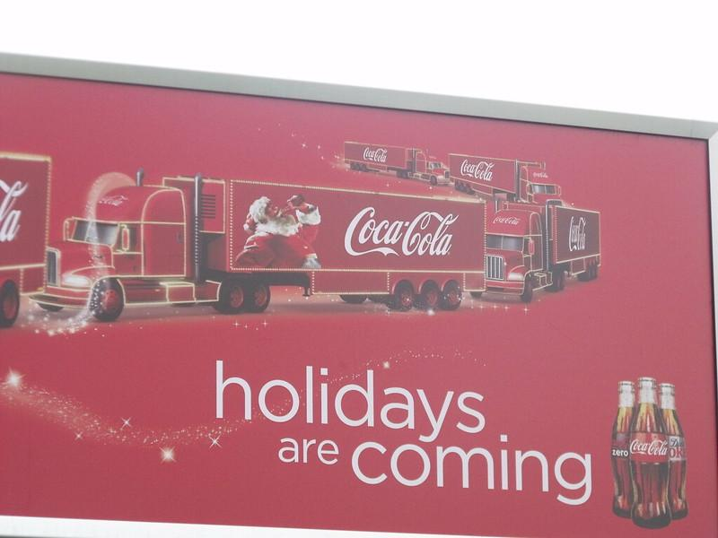

For example, this is a famous billboard by Coca Cola in Stratford Road, Shirley, UK.

### Reach and campaign success

We always measure the success of a campaign by the reach it has. Facebook for business has conducted studies by tying up with multiple partners for a study into this.1

They worked with renowned market research company Kantar to evaluate a campaign for a french yoghurt manufactured called Les 2 Vaches. The brand was new to the industry and in order to initiate growth, they adopted a multichannel approach.

It involved using TV spots, Facebook ads and OOH ads. The study inferred that Out of Home adverts were able to penetrate existing customers the most and used in tandem with Facebook it was at its most efficient with 13% more efficiency as opposed to OOH adverts alone.

This shows us that it is always important to think of a means of combining verticals for greater reach. For Outdoor Advertising deals to reach maximum potency it is important to include all possible avenues in our agency.

The study also revealed that there was a 6% incremental sales increase after a combined effort through Outdoor Advertisement deals with Social Media Giant Facebook’s participation.

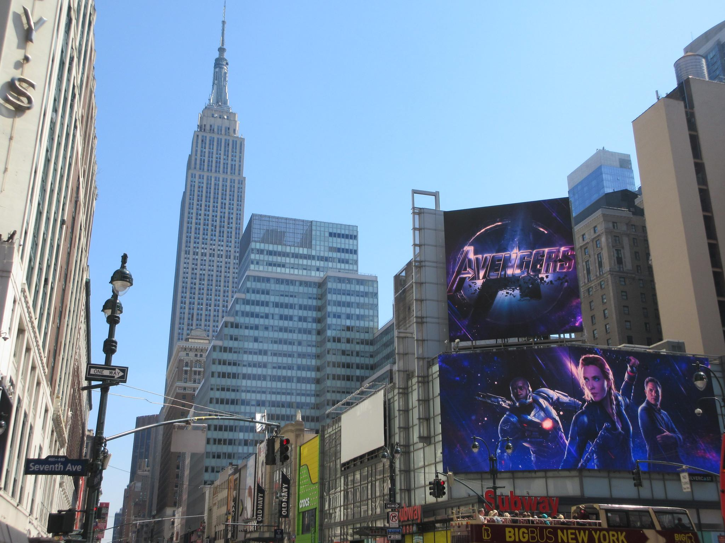

Avengers endgame poster at Empire State Building in NYC

Similar research from Accenture showed us that Gen Z’s and millennials from the EMEA region i.e the younger audiences were having a much higher likelihood of getting a reaction from Out-of-Home ads combined with Facebook as opposed to conventional modes of television ads and print ads.

### Organic Search and Out of Home Adverts

The organic search-driven by Outdoor advertising is significant. It can be illuminated through the statistical analysis by Touchpoints data.[2]



Captain America The First Avenger Billboard

It shows that there is high visibility reach for OOH adverts. More than 70% of people over the age of 18 have noticed an Out-of-Home advert at least once a week. This also seeps down to searches in the social media spectrum with the same number boosting digital searches.

A similar trend is noticeable in the US wherein 4 in 10 adults[3] surveyed said to have visited a Facebook channel or posted on the platform after viewing an OOH advert. And similarly, 25%[3] of the viewers are said to have posted on Instagram. This shows us that there is a verifiable organic search result boost after an Outdoor Advertisement campaign.

DOOH(Digital out-of-home) have seen significant improvement in the last quarter at 16% as opposed to Static out-of-home ads. An advantage of this system is the ability to tune the advert to the client’s vision incorporating multiple images or viewpoints into a short clip and slowing or speeding the frames,

### Out-of-Home Adverts are here to stay

Out-of-Home advertisements started their life through a simple slate with hieroglyphics and then progressed to lithographs in the 1800s and from there to illustration with colour and later to billboards. Now, after the technological revolution, we have seen its improvements reflected everywhere including Outdoor advertising. We have only seen that OOH ads have to get an edge through the incorporation of audio, videos and graphical art, they are eternally part of advertising history and cannot be replaced.

The allure of stepping out of your home and watching a 3D LED 900 sqm screen with a spaceship emerging recently went viral in China and then later to the world. That single frame shows the future of adverts. The integration of AI and Machine learning can enhance our ability to understand organic search boosting by viewing a single such game changer advert.

With intelligent design and incorporation of other social media platforms, with outdoor advertisements, we can further drive audience interest and make it more interactive.

**Bibliography**

1. Facebook. (2019). *Maximise reach with out-of-home and Facebook campaigns in EMEA*. Maximise reach with out-of-home and Facebook campaigns in EMEA. https://www.facebook.com/business/news/insights/maximize-reach-with-out-of-home-and-facebook-campaigns
2. IPA. (2018). *2018 TouchPoints data shows growth in the SVoD category*. Touchpoints. https://ipa.co.uk/news/netflix-viewers-soar-by-45-yoy
3. Neilson. (2017). *OOH, Online Activation Survey*. Neilson. https://omac-website.s3.amazonaws.com/wp-content/uploads/2017/05/Nielsen-OOH-Online-Activation-Study-2017.pdf
4. Statisa. (2021, January 25). *Out-of-home advertising - statistics & facts*. Out-of-home advertising - statistics & facts. Retrieved March 5, 2021, from https://www.statista.com/topics/3258/out-of-home-advertising/#:~:text=The%20OOH%20advertising%20market%20in,than%2017%20percent%20in%202021.